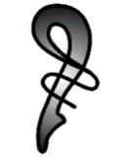
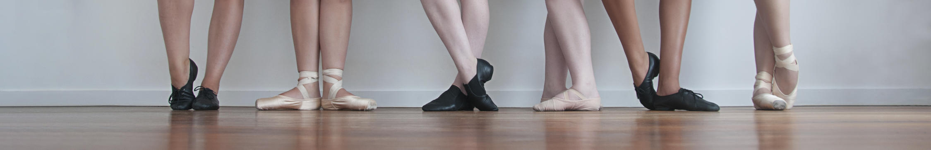
Photo by Vividity Photographer Jennifer Taylor

NORTHERN BALLET STUDIOS

COVID 19 SAFETY PLAN

Please could everyone abide by the COVID-19 guidelines and restrictions at the following link;
- https://www.nsw.gov.au/covid-19
- https://www.nsw.gov.au/covid-19/what-you-can-and-cant-do-under-rules

Wellbeing of staff, parents & students

- Any students feeling unwell must stay home and not attend class
- Staff who are sick should stay home and notify manager.
- Please observe and obey all signages for the wellbeing of everyone.
- Please do not enter the church premises if you have experienced any flu-like symptoms of COVID -19 or have been overseas or interstate within the previous 14 days or in close contact with anyone who has had symptoms.

Drop off and pick up procedures

- Please drop off and pick up students as close as possible to their starting and finishing time so we can meet the social distancing rules.
- There cannot be more than 5 people in the waiting area at one time.
- Please stay in your car until there is space in the waiting area.

Hygiene & Cleaning

- We encourage students to dress in their dance wear prior to arriving for class if possible to avoid change rooms.
- Students must sanitize their hands prior to entry & exit of the studio. Sanitizing stations are available at the entry of each studio.
- Belongings should be kept separate to avoid contact with others.
- Partner work is not permitted.
- Prop used only if disinfected prior to use.
- Students are to bring own water bottles, towels and exercise/stretching mats.
- Any left or unclaimed water bottles will be discarded.
- The ballet barres will be wiped and disinfected between classes
- Staff will disinfect sound system after use.
- Staff are encourage to regularly clean their own personal equipment including mobile phones, iPad, computers etc.
- Cleaning products & procedures for staff will be stored in the cupboard.
- Windows will be keep open during class for good ventilation.
- Payments are encouraged to be by bank transfer where possible.

Physical distancing

- Maintain 1.5m physical distance from each other, in and out of class.
- Please follow all signage regarding maximum number of people in each areas of the church premises.
- No hugging or high-five.
- Teachers are reminder to remain 1.5m from students
- No classes to be observed by an audience

Record keeping

- The student Roll book will be marked each class by teacher
- Information (name , mobile numbers & emails) of Staff, parents & students will be stored confidentially and securely and will only be used for the purposes of tracing COVID-19 infections.
- Anyone who enters the premises apart from student attending class must enter their name & mobile into the book provided to assist with contact tracing if required.
- Northern Ballet Studios will cooperate with NSW Health if contacted in relation to a positive case of COVID-19 and notify SafeWork NSW on 13 10 50.

